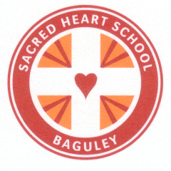

Sacred Heart Catholic Primary School
Floatshall Road
Baguley
Wythenshawe
M23 1HP
Phone:
(0161) 998 3419
Fax:
(0161) 945 6507
E-mail:
admin@sacred-heart-baguley.manchester.sch.uk
15/12/14
Issue 1
Sacred Heart Catholic Primary School Newsletter

Class Assemblies
September – November 2014

Year 3 opened with a beautiful celebration of our families.
Year 1 performed a wonderful assembly about different toys they had been exploring in class.

Year 4 delivered an assembly on the Holy Bible and how this guides our lives

Year 2 explored the bible story King David, and told us how we could lead better lives

Year 5 retold the story of the Prodigal Son in a very engaging assembly.

Year 6 led a beautiful Remembrance Day service, providing us all with the time to reflect on the pain of Wars.

Reception shared a lovely assembly how to be a good friend.

Please try to join us for our Good News assembly every Monday morning
9.10AM
Dear Parent:
Welcome to our first edition of Sacred Heart News this year.

Firstly, there have been a few changes around school and we would like to thank you for your co-operation and continued support.

We aim to send out a newsletter each half term to celebrate the many events that have taken place at Sacred Heart.

In this edition you will see that children have been completing many exciting activities both inside and outside of school; from visits to Lyme Park and the Lowry Theatre, to an engaging ‘Sokka Project’ and the launch of our new Maths initiative called ‘Numicon’. Children have experienced a range of learning opportunities which they have found fun and challenging. We’d like to share some of those with you now.
We hope you enjoy reading!

NEW WEBSITE launching January 2014:
www.sacredheart-baguley.manchester.sch.uk
Religious Life
As we near the end of the season of Advent the children have been reflecting on the year and how to prepare for the coming of Our Lord Jesus, during this time of waiting in hope, love, joy and peace.
Each week children have been involved in a special Advent assembly for a quiet time of reflection. Children have lit candles on the advent wreath, both in assemblies and in classrooms. Children have also had the opportunity to be involved in a Reconciliation Service in Church with Father Chris.
Sacramental Programme
The year 3 children have enrolled onto a programme of preparation for the Sacraments of Reconciliation and Holy Communion.
Friday Class Mass
Children have enjoyed going to church each Friday, on a rota basis, to join parishioners in a celebration of Mass at 9:30am. All are welcome.
Marist Centre Visits
On Monday 8th December 2014 Year 4 and Year 5 visited the Marist Youth Centre for an Advent retreat day. The day gave the children chance to have some quiet time to reflect on the special season of Advent, and think about some of the themes of Advent through singing, poetry, drama and prayer.
Mission Together
In early October we launched our ‘Missio Together’ Project to help support the children of Cambioda through fundraising and prayer. We will continue to raise awareness with children and hope you will continue to support our charity work.

We pray
May all children
In the world
Share love
Share friendship and live
In the peace
Of God’s love
Now and forever Amen



Book Fair

A HUGE thank you to all parents who came along to our Book Fair!
We managed to raise £220 to spend on books for our library ☺
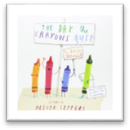

Page 2 of 6 School News
Reading at Sacred Heart:
Books, Books and more Books! We’ve had a real drive with reading this year! We have purchased a brand new Guided Reading scheme throughout the school. All of the books are popular; the children will just love to read them! They range from classics such as The Gruffalo and Goodnight Mr. Tom, to some newer books like The Boy in the Dress by David Walliams, to Marley and Me! All staff have received training on how best to deliver a Guided Reading session and the children are loving having their teachers read to them! As in the past, many helpers are coming into school to hear your child read each week. We’ve also launched a new Reading intervention project called ‘Project X Code’. Children who have been selected will receive an extra 30 minutes each day to support their comprehension and phonic awareness. It is proving to be very exciting! Please support us by sharing your favourite stories with your children each night – not only does it help their reading ability, but it also has a huge impact on their writing!
“A child who reads will be an adult that thinks!”
School Council
Sacred Hearts’ School Council have had a very busy term so far, with lots of important decisions to make!
Mrs Bramhall set them their very first task, which was to work with the designers at ‘Creative Play’. The Council had to propose ideas for replacing our condemned Trim Trail on the playground. The children all did an excellent job of expressing their interests and negotiating costs! Work on the new Trim Trail will begin in February and our School Council will have a hands on role in this.
In addition they have helped to raise money for Mission Together by advertising the cake sale. They have worked extremely hard over the last term and I’m sure this will continue in the Spring.

Attendance
The children are doing really well with their attendance so far this year. See below for your child’s class attendance:
Autumn 1  2014 |  | Autumn 2 2014
NUR | 96.6% | NUR | 94.9%
REC | 96.7% | REC | 97.2%
Y1 | 97.8% | Y1 | 94.3%
Y2 | 96.6% | Y2 | 95.3%
Y3 | 96.5% | Y3 | 97.1%
Y4 | 98.2% | Y4 | 96.0%
Y5 | 97.4% | Y5 | 97.8%
Y6 | 96.5% | Y6 | 96.0%
Whole School | 97.0% | Whole School | 97.0%
Remember, it is important that your child attends school on time (8.50am) everyday. If your child is too poorly attend, you must phone school on each morning of their absence!

Numicon:
We have invested in a range of teaching materials, called
Numicon, to aid children in their understanding of number. Numicon is a multi-sensory approach to teaching maths. It is designed to help children understand connections between numbers. Children will develop the understanding and skills that underpin their later understanding of number. The children are loving using it!
Curriculum Night and Parents’ Evening
During the first few weeks of term, we held a curriculum open evening, which gave parents the opportunity to meet teachers and teaching assistants. The teachers detailed the curriculum that children will be following and offered tips for support and guidance. This evening was greatly received and it is something we hope to continue.
In November we held a parents’ evening, which was also greatly attended. Parents discussed with the teacher their child’s progress and achievements. Remember, we are only a phone call away if you wish to speak to us!

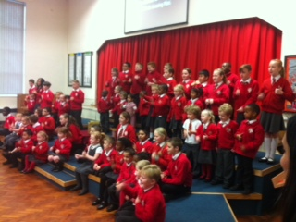
e
.
Page 2 of 4
School Newsletter
Year Group News
SPECIAL FRIENDS
In the first few weeks of term, Reception children and Year 6 children got together to choose SPECIAL FRIENDS.

Names were drawn out of hat and each Year 6 child was paired with a Reception child.

The Year 6 children will visit their Special Friend once a week to support them with their work and set a good example.

Nursery News:
Wow! We cannot believe how well the children in our Nursery class have settled. We have had so many comments from members of staff about their fantastic behaviour and how beautifully they sit and listen in assemblies. We are certainly very proud of them. This has been such a busy term! We have covered 2 topics so far. During our “All About Me” topic, the children learnt that everybody is different. They made amazing self-portrait collages and learnt how to write their own names. We learnt about how God created the world and they performed a super Creation dance. This half-term, the children have been learning about “Light & Dark”. They have learnt all about different light sources and also about nocturnal animals. We have read lots of stories about the dark, including one of our favourites, Whatever Next! We used 2D shapes to make rocket pictures and also constructed a new rocket for Baby Bear out of Duplo and Mobilo. The children are having such a lovely time learning about the Nativity story and we were so impressed with their Christmas play, Donkey For Sale! They have written letters to Father Christmas and have made some lovely Christmas cards. Phew! Keep up the hard work Nursery!

Reception News: It has been all light and dark in Reception and we have had a very exciting term! We have been very lucky to have Miss McIntosh with us and what a lot we have learned together.
Maths has been all about capacity – is your bottle full of empty?

We have had great fun getting to know Day Monkey from our topic story book. It was written by Julia Donaldson. We’ve asked him questions, given him instructions and performed a lovely assembly and Advent play! What a busy and enjoyable term is has been.
Year 1 News: We’ve had an excellent start to the year, learning all about sentence-writing in Literacy and we have started some addition and subtraction work in our Numeracy lessons, as well as looking at some of our times tables and number bonds. In R.E. we have been talking about the book of Genesis and how God created our world and the children have enjoyed performing their Christmas play based on the Nativity story. The children have also really enjoyed our History topic, looking at toys from today and from the past and they thoroughly enjoyed their trip to Lyme Park recently, where they discovered more about Christmas traditions from the past and explored some of the activities children enjoyed long ago. The Year 1’s have behaved sensibly going up to the Computer Suite for Computing lessons this term, and are now able to log onto their own computers quickly! They’re becoming adept at using the Paint program and tools to draw and label pictures!! What a busy and productive Autumn term we have had. Well done Year 1!

Year 2 News: The year 2 class have made an extraordinary start to the year. Over this last term the children have covered a breadth of literacy work, with a focus on; sentence structure, punctuation, text organisation, spelling and handwriting. The children have worked incredibly hard to use connectives to make compound sentences, eg. and, but, because. In numeracy we have learnt to recognise fractions of shapes and learn number bounds to 20. I have seen all the children make a huge effort to learn their 2, 5 and 10 times tables. In Science the children have enjoyed learning about the life cycle of humans, frogs and butterflies. They have developed an understanding of the importance of exercise and a good diet in order to stay healthy. In Religion lessons the children have reflected on and discussed a range of Bible stories including Daniel and the Lions, Moses, Abraham and the Nativity story. The children have led some thoughtful discussions and continue to amaze me with their awe and wonder of God’s world. Keep up the hard work year 2 and have a lovely Christmas break.
Just a reminder that PE lessons are on Monday, Thursday and Friday. Homework is due in on a Tuesday and reading books are changed on a Tuesday and Friday.

Religion Topics next half term:
Nursery:
Getting to know Jesus

Reception:
God’s World

Year 1:
Families and Celebration

Year 2:
The Good News

Year 3:
Sacrament of Reconciliation

Year 4:
Jesus, the teacher

Year 5:
Inspirational People

Year 6:
Jesus the Bread of life
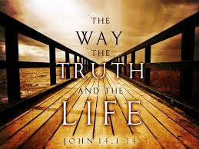

Page 3 of 6 School News
Page 3 of 4
School Newsletter
Year Group News

Page 4 of 6 School News
Year 3 News:
Year 3 have worked their socks off during this term! It is hard to believe that they have only been junior children for a term as they are so grown up and sensible! In our literacy lessons we have been writing funny poems and researching about penguins before creating our own information text. In our numeracy lessons we have been learning about place value, addition and subtraction, fractions, and shape. We will be building on our knowledge in the coming months. In our topic lessons we have been learning about Stone Age to Iron Age Britain and finding out about the Geography of the world and Great Britain. In Science we have learnt about “Light and Dark” and we have also begun to learn about Forces. In our religion lessons we have been learning about the Christian Family and considering the importance of Mary, Our Mother. What a super term we have had Year 3! Keep up your hard work!

Year 4 News:
What a fantastic start to the year! I have been so impressed with their sensible attitudes to everything that we do. We have been going swimming each Tuesday and I have been amazed to see what talented swimmers some of the children are! Many of the children have received their 10 and 25 metre certificates. We have received numerous compliments about our excellent behaviour, which makes me very proud! We have performed our first class assembly all about the Bible – the children loved preparing their singing and acting. The children have enjoyed taking part in lots of sporting activities during school, at lunch time and after school. They have particularly enjoyed working with the Manchester United football coaches on a Friday. We have also been working hard raising money for children in Cambodia through Mission Together, and have held cake sales and are collecting money in our special money boxes. We have enjoyed a trip out to the Marist Centre with Year 5 to reflect on the season of Advent, which all of the children really enjoyed. Of course, over the last few weeks we have been busy preparing for Christmas, where the children have been displaying their creative talents. What a busy and enjoyable term it has been Year 4 – I am sure Father Christmas will be sending you all lots of treats!

.

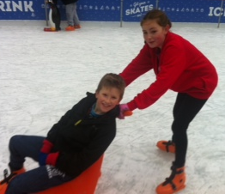
Year 6 News:
Year 6 have made an absolutely excellent start to the year! They have quickly settled into their role as the older members of the school and have impressed us with their maturity, hard work and positive attitude.
They have helped the Reception children settle into school life by becoming their special friends and have shown themselves to be a very kind and caring class. As prefects they have taken on greater responsibilities around the school. Our trip to the Lowry Museum to study War Horse inspired them to produce some outstanding writing and art work. The children took responsibility for writing and performing our schools Remembrance Day Assembly, which they completed with a great deal of respect and maturity. They have also shown how charitable they are in helping us to raise money for the children in Cambodia. During the past month there has been a focus on Advent as a season of preparation and the Year 6 children led our Reconciliation Service. They have been a delight to teach this term and their hard work and effort has recently been rewarded with our metro link journey to Spinningfields ice rink, an excellent day out!
The children have finished this term by putting their amazing voices to excellent use, performing their
Christmas concert at Manchester Airport, to the parishioners and their families.

We hope that the children have a wonderful Christmas break and are ready to return full of excitement
and exuberance for the Spring term.

Year 5 News:
Year Five have enjoyed a fantastic first term! I have been so impressed by the excellent attitude to learning demonstrated by all of the children in our class. In our literacy lessons we have loved reading different myths and legends, we even had a go at writing our own! During our unit of work on classic fiction we studied The Railway Children by Edith Nesbitt. Using this text as a starting point, the children have produced lots of high quality writing across a range of genres. In numeracy we started the year working really hard to use and apply our knowledge of the four operations. We have been using this to help us with our most recent work converting between fractions, decimals and percentages. In religion we started off by thinking about the gifts we have been given from God and how we can use these to be good stewards of the Earth. Year Five have thoroughly enjoyed learning about the Mayans and the Americas for their topic work which we will continue next half term. Our class have been very fortunate enough to take part in a Disability awareness course run by volunteers from City in the Community, children really took a lot from the experience and even had the chance to create their own superheroes! Finally, last week Year Five had a fantastic time watching lots of talented pupils from St Paul’s High School put on a performance of Calamity Jane, I’m sure the next term will be just as exciting as the first!

It has been a term of great success in Sports for our boys and girls this term.
During the school day we have plenty of sporting opportunities for children: MCFC Football at lunch, MUFC Football for Years 3 and 4, Lacrosse Clubs, Netball Clubs, Dance Clubs and after school football for boys and girls!
What a range of great activities to keep your children fit and healthy!!

School Newsletter

Page 4 of 4
Page 5 of 6 Sports News School News
We have had plenty of Sports Success this half term: Cross Country, Boys’ Football, Girls’ Football and Lacrosse! It’s time to celebrate!

Children have also had the chance to take place in many competitions.

Year 4/5 Boys’ and Girls’ Football: some of our keen footballers in Years 4 and 5 have now completed two rounds in a city wide football tournament. These games have taken place at the Etihad Campus, home of champions Manchester City – what a great venue to play at! Children have been a delight to take and always well behaved! Both teams won many games and showed great sportsmanship!

Year 6 Girls’ Football: Alex, Phoebe, Sylwia, Molly, Lily, Faith and Megan took place in a Wythenshawe league, which was held at Newall Green High School. The girls’ did really well and gelled as a team almost immediately. They had some great wins, a few losses and a couple of draws!

Year 5/6 Boys’ Football (written by Kirby):
Billy, Isaac H, Isaac M (Captain), Josh, Thomas H, Mason, Kirby and Faolain took
place in three weeks of football action at St Paul’s High School.
The boys’ league lasted for 3 weeks with 9 teams competing. We topped the league in
a close battle with St Anthony’s (what made it more interesting is we won on goal
difference!
We had a great experience and are looking forward to the City Wide Finals!

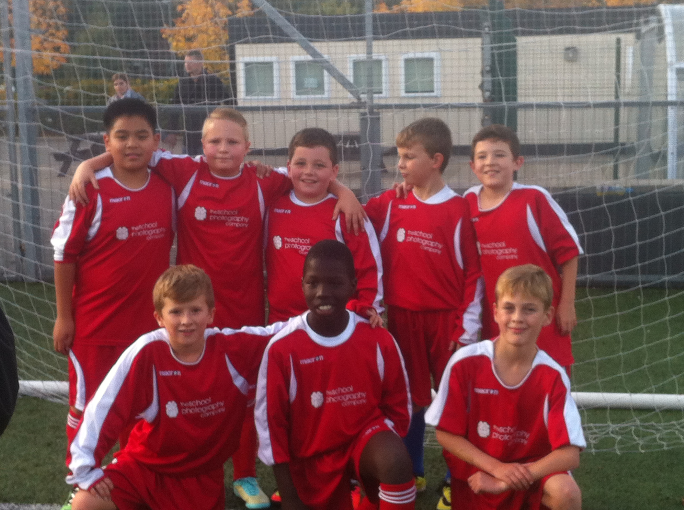

Cross Country:
At the beginning of the year, 24 children across Year 5 and 6 took place in a
Wythenshawe Cross Country League. Children had to battle it out against schools from Wythenshawe and South Manchester. They ran a very, very long course and achieved some great finishing places. Our boys’ team managed to go through to the City Wide Finals and
Philips Park, including two of our girls!
At the finals the boys faced competition from schools all over Manchester –
they finished in great position but sadly missed out on a winning trophy.
All the children we’re able to take part in Manchester’s annual ‘Fun Run’.
It was a great afternoon out (apart from the rain) and it was great to see
many supporters with us.

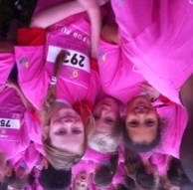

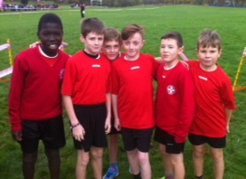

Overall, it has been an amazing term of sport achievements and we look forward to many more over the rest of the year!! Thank you to all adults and children who came along to support each team.

Spooky Disco
On Thursday 4th November we held our
SPOOKY DISCO in the school hall!
The disco was a fantastic, spooktacular, spine tingling success and great fun was had by all! Thank you for everyone’s
great effort with their costumes!!!

Page 6 of 6 School News

Foundation Stage Update:
Down in Nursery and Reception, we have been really lucky to benefit from a huge investment to help develop the classrooms.
New furniture and resources have now been installed, which has meant a vast improvement to the continuous provision available to the children throughout the day. This has been a huge success already and both the children and adults are loving our new learning environments!!!



Christmas Fair
Once again the Christmas Fair as a great success. We have to give a big thank you to everyone who donated something on the Fridays prior to the fair! Lots of effort went into the night and it was greatly appreciated. We raised lots of money and everyone had lots of fun!
Thank you for your support.

Universal Free School Meals
All children in our Infants
are now enjoying a free
school meal in school.
It has proven to be a
great success!!



School ‘Public Address’ System
We have updated the sound
system in the school hall,
incorporating a PA system.
I am sure that this will serve
to enhance the acoustics
during our class assemblies
and productions.




Airport Visit
On Friday 12th December 2014 some of our Junior children went to visit Manchester Airport to spread some Christmas joy to people working at and travelling through the airport. The children travelled around different parts of the airport sharing how children in other countries celebrate Christmas, they told the Nativity Story and sang some traditional Christmas carols.

The children had great fun at the visit, and we got so many compliments on how beautifully the children sang and how excellent their behaviour was. A big well done to all of the children involved!

A final note:
We really hope you’ve enjoyed reading about all our success this term. It has been a great term full of fun, enjoyment and lots of learning!
From all at Sacred Heart
Catholic Primary School we
wish you a very happy and
Holy Christmas, and a
wonderful New Year!

